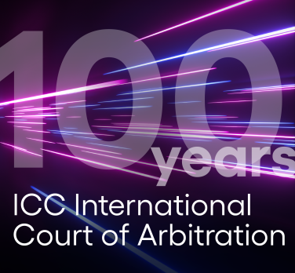
To mark 100 years of the International Court of Arbitration of the International Chamber of Commerce (ICC) has issued its ICC Centenary Declaration on Dispute Prevention and Resolution setting out a vision and guiding principles for the future.
Ms Claudia Salomon, ICC Court President said:
“As business relationships and disputes evolve in an ever-changing world, ICC’s track record of innovation places us in the perfect position to lead the world of dispute resolution and prevention into the future.”
As well as committing to the ICC Court’s purpose to enable access to justice and the rule of law, the Declaration sets out commitments and principles for the development of further pioneering ICC tools and services that aim to better serve the global dispute resolution community – including businesses of all sizes, sectors and geographies.

The world’s preferred arbitral institution
Inaugurated in 1923, the ICC Court is recognized today as the world’s preferred arbitral Institution. The key milestones in the ICC Court’s history include helping to broker the Geneva Convention on the Execution of Foreign Awards in 1927 and submitting the preliminary draft convention of what has become the United Nations New York Convention on the Recognition and Enforcement of Foreign Arbitral Awards in 1958.

The Declaration is accessible at here [2023-icc-court-centenary-declaration-en.pdf (iccwbo.org)

Watch the global launch of the ICC Court Centenary
Please click here [https://youtu.be/GSEIv166a5A ]

** The International Chamber of Commerce (ICC) has celebrated 100-year anniversary on 2019 marking as the world business organization **

